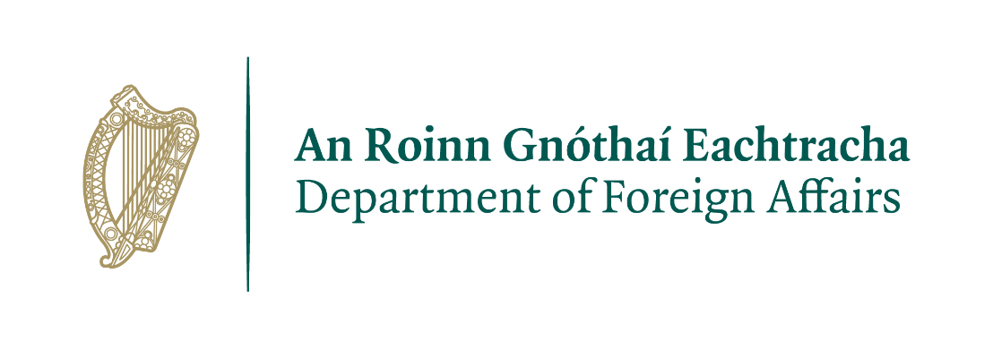
Temporary Clerical Officer Passport Service - Balbriggan - Application Form

Please submit completed forms to PassportTCO@dfa.ie by:
Noon, Friday 16th February 2024

Applications must be typed and saved in Word or PDF format

Please tell us how you heard about this position:

Personal Details

Name
Telephone
Postal address
E-mail address
Citizenship

I am willing and able to communicate with customers through Irish/Irish Sign Language – Yes/No

Where relevant, please provide a brief description of Irish/Irish Sign language qualifications and skills:
If you require any reasonable accommodations to be made at any stage of the selection process, please let us know by stating your requirements below and we will make the necessary arrangements to assist you
2. Education

School/College | From (Year) | To (Year) | Examination | Results

3. Career History
Please detail your career in reverse chronological order so that the most recent roles appear first. Ensure that you detail all relevant work experience, including details of any employment in the Civil or Public Service. Add additional boxes if required.

Current or most recent role:

Position / Job Title  (Reason for leaving if applicable) | Organisation / Company name and address | Dates from – to
Main Responsibilities & Achievements:

Outline experience, in this position, relevant to the role:

Previous roles:

Position / Job Title  (Reason for Leaving) | Organisation / Company name and address | Dates from – to
Main Responsibilities & Achievements:

Outline experience, in this position, relevant to the role:

Position / Job Title  (Reason for Leaving) | Organisation / Company name and address | Dates from – to
Main Responsibilities & Achievements:

Outline experience, in this position, relevant to the role:

4. Self-assessment
Please provide example(s) of your level of competence under each of the three competency headings below, you should be specific about the task or project e.g. why it was important, how you went about it, what your specific role or contribution was and the impact or outcome. Please refer to the PAS Civil Service Clerical Officer competency framework. Strictly no less than 100 words and no more than 200 words per competency.

Information Management/ Processing
Word count:

Delivery of Results
Word count:

Customer Service & Communication Skills
Word count:

5. Computer Skills
Training in the relevant computer applications will be provided. However, proven ability to use computer systems and proficient keyboard skills are essential. Please rate your level of proficiency in each of the areas below by ticking the box most applicable.

How would you describe your proficiency in Microsoft Word?

Excellent
Very Good
Good
Fair
No Knowledge

How would you describe your proficiency in Microsoft Excel?

Excellent
Very Good
Good
Fair
No Knowledge

How would you describe your proficiency in Microsoft Outlook?

Excellent
Very Good
Good
Fair
No Knowledge

How would you describe your proficiency in typing skills?

Excellent
Very Good
Good
Fair
No Knowledge

6. Suitability for the Role

Please give a brief outline of why you are interested in this Temporary Clerical Officer position, and the particular skills, qualities and experience you would bring to the role. Strictly no less than 150 words and no more than 250 words.

Word count:

7. References
Please provide the following information in respect of two referees, one from your most recent supervisor (either work or academic).

Name:

Title/Position:

Address:
Email:
Tel:

Name:

Title/Position:

Address:
Email:
Tel:
Please tick the box if you do not wish for us to contact these referees without notifying you in advance.

IMPORTANT NOTE

The Passport Service holds highly sensitive information relating to the identity of Irish citizens. For this reason, security in terms of personnel and work process are of primary importance. Applicants therefore must, accept before entering the recruitment process that any contract offer is contingent on a satisfactory completion of enquiries and checks by An Garda Síochána regarding their suitability for employment in these sensitive positions. Applicants should therefore be aware that where any doubt regarding the suitability of a candidate arises from this vetting process, an offer of a contract will not be made.

ACKNOWLEDGEMENT: I note and accept that assignments will be to a temporary position. The duration and period of a temporary contract will be 6 months. There is no entitlement to a permanent position.

Notwithstanding the above paragraph on tenure, the Department of Foreign Affairs retains the right to consider holding a confined Selection Process for established appointment to certain positions within the Civil Service in certain limited circumstances.

DECLARATION: (I) I declare that the facts contained in this application form are true and correct.

(ii) I can confirm that I am not in receipt of a public service pension from an incentivised early retirement.

(iii) I declare that I am willing to allow security enquiries be made of the Garda Síochána regarding my suitability for a position in the Passport Service. I understand that any information released to the Department of Foreign Affairs in this regard will be held in the strictest confidence. I fully accept that a failure to pass the vetting process will rule out an offer of employment in the Passport Office.

SIGNATURE: ______________________________________________

DATE: ______________________________________________

Checklist:
Please submit the following to passportTCO@dfa.ie by Noon, Friday 16th February 2024

  - Fully completed typed form saved in Word or PDF format

  - Scanned copy or photo of your valid government-issued photo ID

Applications should only be submitted using this application form. CVs will not be considered as applications.

Applications saved in the incorrect format or handwritten will not be considered.

Applications that do not include valid government-issued photo ID will not be considered.

